**Power Bi Desktop**

**Assignment – 1**

1. **Screenshot of the report view page**

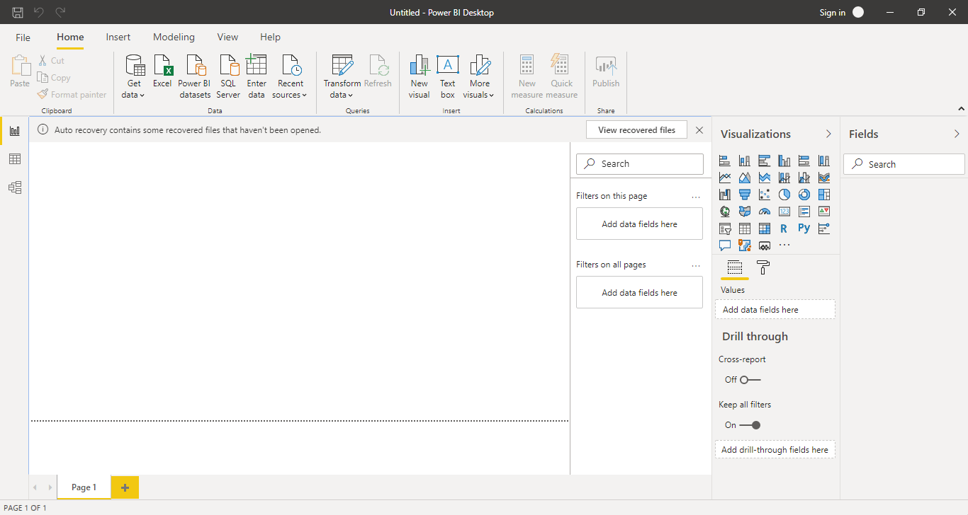

1. **Screenshots of the following pages:**
2. Report View – Report view is used for Visualizing the data with many visualizing tools such as Bar chart, Column chart, Table, Card, etc..

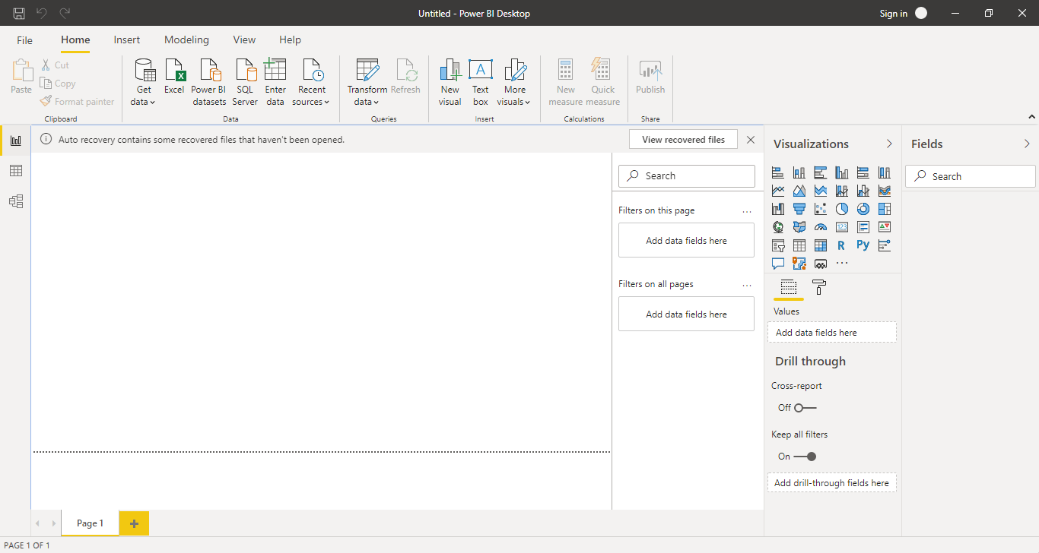

1. Data View – Data view is used in Data Modelling

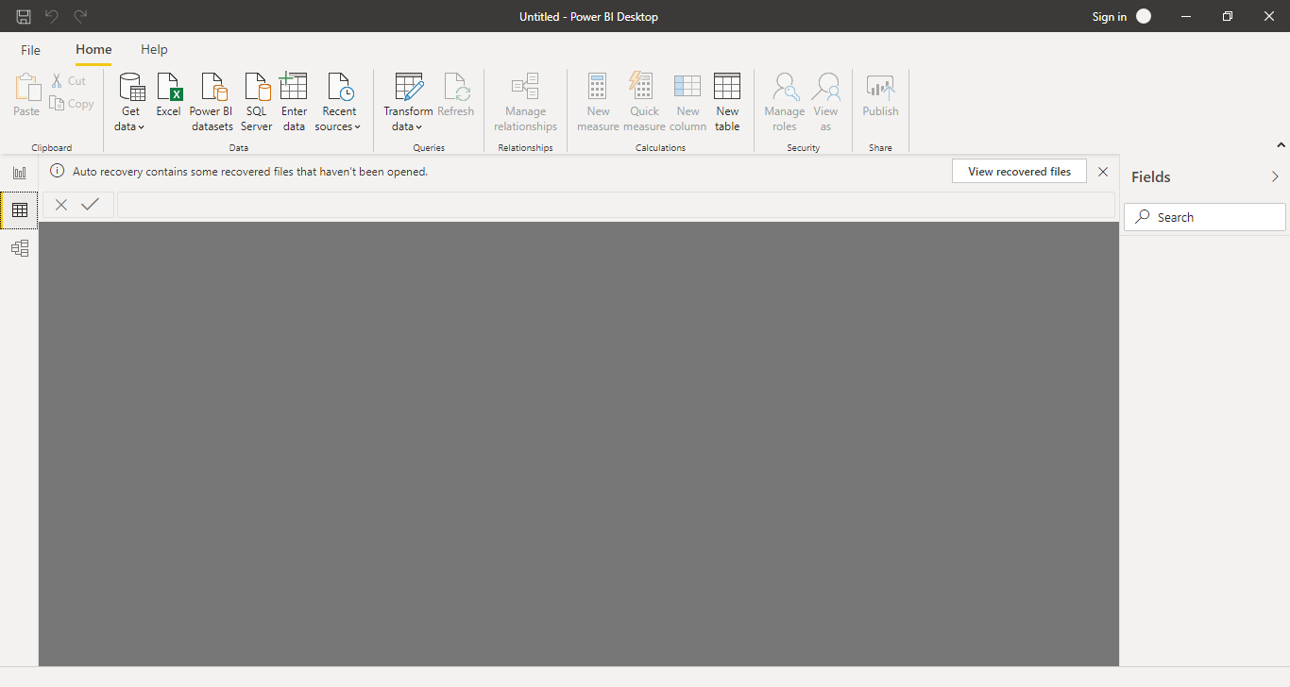

1. Model View – Model view is used to work on the data schema and relationship between the data

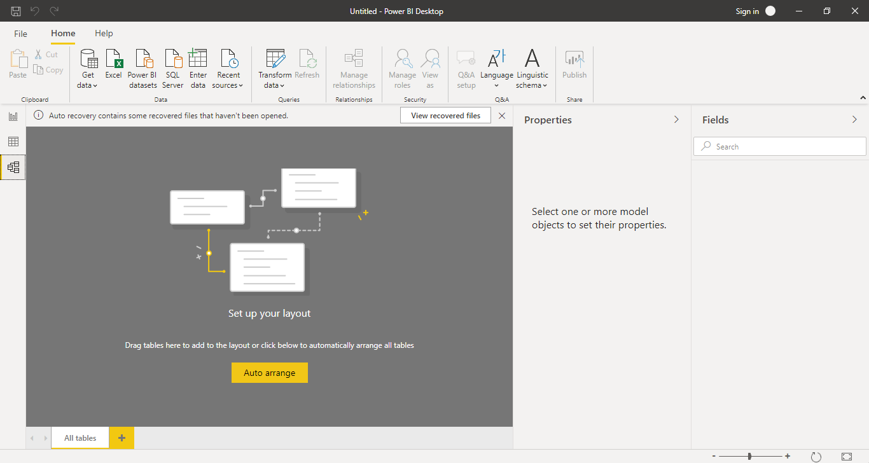

1. Power Query Editor – Power Query Editor is an ETL tool for Power Bi Desktop. It is used for formatting the data.

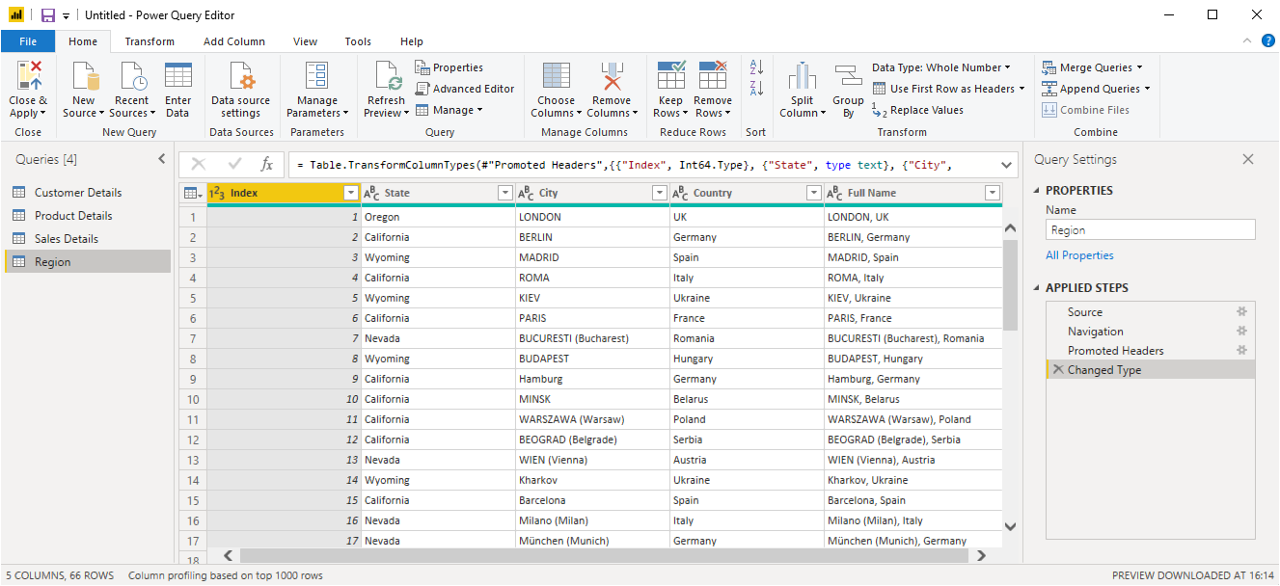

1. Advance Editor – We can create an interface to enter the input/data and to understand the Power query transformations

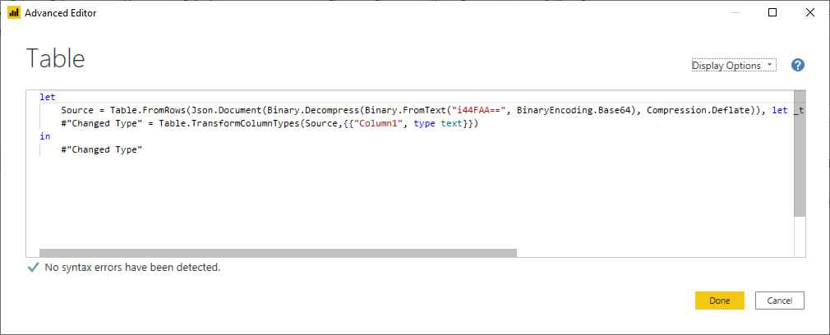

1. **Price**

* Power BI Desktop 🡪 Free for individual users
* Power Bi Pro 🡪 costs $9.99 for single user per month
* Power Bi Premium 🡪 plan starts from $4,995 a month per dedicated cloud compute and storage resource